GitHub Flow

What is GitHub Flow?
# Source: AI Source: Provided by: [Data Path: Persons Table -> ID Column: 1, Name_En Column: Motasem Essam] -> From: [ChatGPT] on [2/15/2026]
GitHub Flow is a lightweight, continuous delivery workflow where developers create short-lived branches for each task or feature, collaborate via reviews, and merge changes into the main branch frequently.
It emphasizes simplicity, continuous integration, and keeping the main line of development always deployable.
This workflow is popular for web applications, SaaS products, and teams practicing rapid deployment.

How It Works
# Source: AI Source: Provided by: [Data Path: Persons Table -> ID Column: 1, Name_En Column: Motasem Essam] -> From: [ChatGPT] on [2/15/2026]
- Developers create a new branch for a specific feature, bug fix, or task.
- They make changes in this branch and commit frequently.
- When the work is ready, a pull request (or merge request) is created.
- Code is reviewed by team members and tested.
- After approval, the branch is merged into the main branch, which remains stable and deployable.
- The cycle repeats for the next task or feature.

Conceptual Visualization
# Source: AI Source: Provided by: [Data Path: Persons Table -> ID Column: 1, Name_En Column: Motasem Essam] -> From: [ChatGPT] on [2/15/2026]
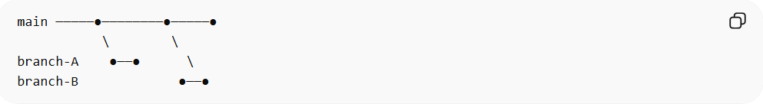
main ─────●────────●─────●
\ \
branch-A ●──● \
branch-B ●──●
Each branch is short-lived and merges quickly into the main line after review.

When It Is Used
# Source: AI Source: Provided by: [Data Path: Persons Table -> ID Column: 1, Name_En Column: Motasem Essam] -> From: [ChatGPT] on [2/15/2026]
- Teams practicing continuous deployment
- SaaS and web application development
- Projects requiring rapid, incremental delivery
- Small to medium teams that prioritize simplicity over complex branching

Advantages
# Source: AI Source: Provided by: [Data Path: Persons Table -> ID Column: 1, Name_En Column: Motasem Essam] -> From: [ChatGPT] on [2/15/2026]
- Simple and easy to understand
- Encourages frequent integration
- Keeps main line always deployable
- Supports code review before merging
- Works well with CI/CD pipelines

Disadvantages
# Source: AI Source: Provided by: [Data Path: Persons Table -> ID Column: 1, Name_En Column: Motasem Essam] -> From: [ChatGPT] on [2/15/2026]
- No long-term staging branch; testing must be thorough
- Less structured than workflows like Gitflow
- Can be risky if feature branches are too long-lived or code review is skipped

Key Idea (General Summary)
# Source: AI Source: Provided by: [Data Path: Persons Table -> ID Column: 1, Name_En Column: Motasem Essam] -> From: [ChatGPT] on [2/15/2026]
GitHub Flow = Short-lived branches for each feature → Review → Merge → Main always deployable
It is a lightweight, continuous delivery workflow suitable for teams that need rapid iteration without complex branching structures.

